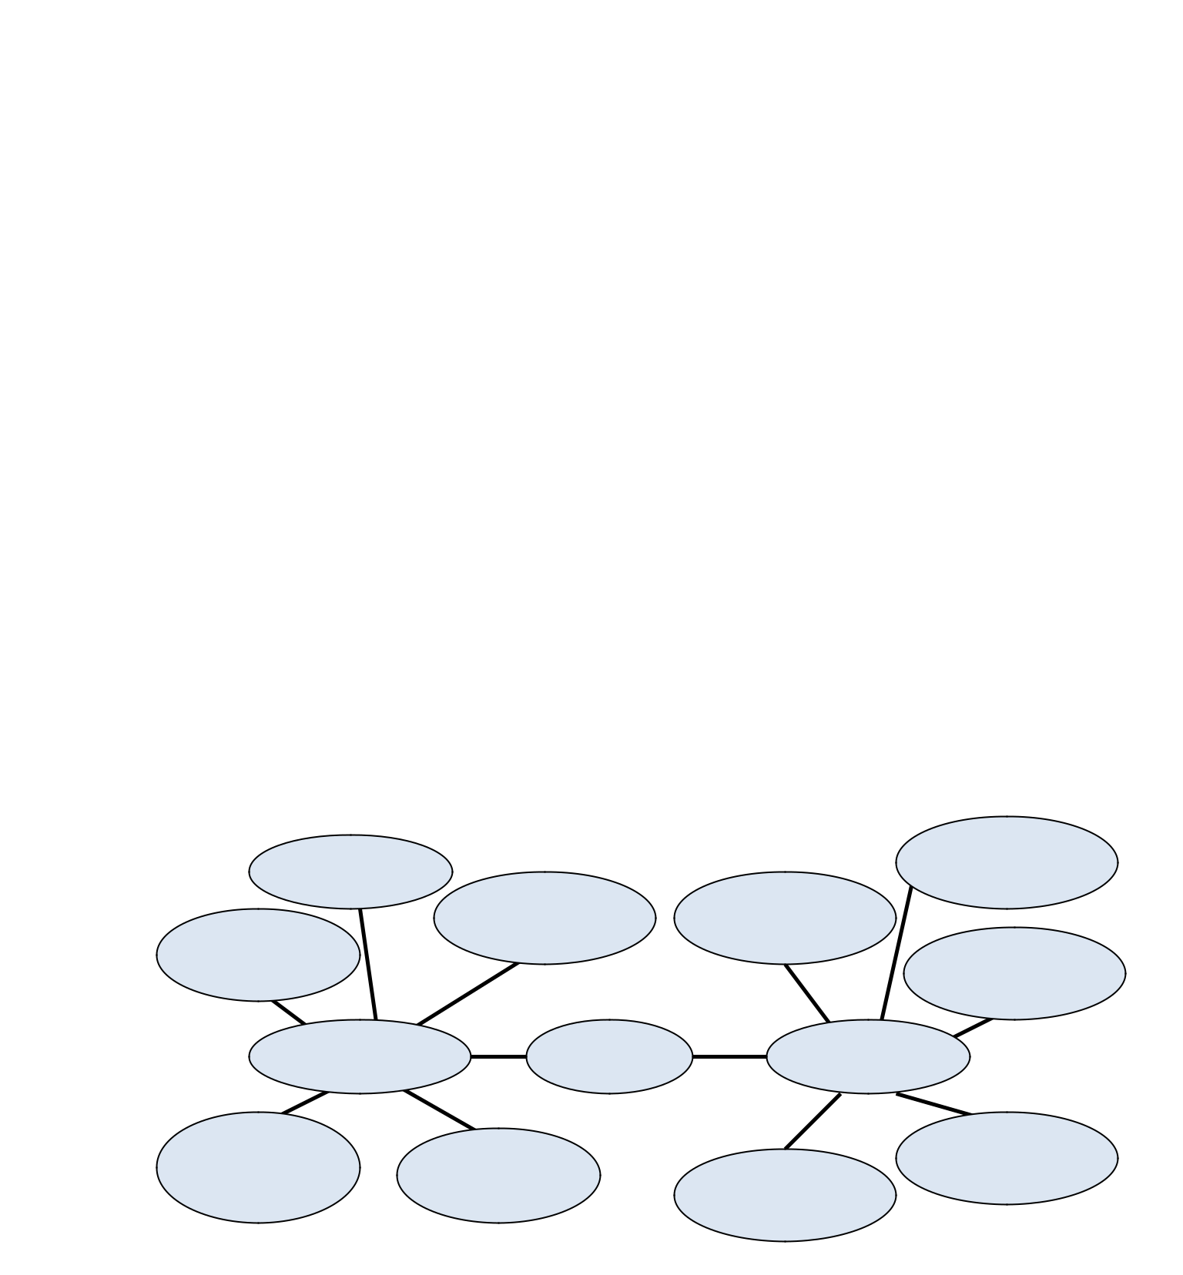
- Prokaryote

____ A prokaryote is a cellular organism that lacks an envelope-enclosed nucleus. ________________________________________________________________________

- Eukaryote

_____ Eukaryotes are organisms whose bodies are made up of eukaryotic cells, such as protists, fungi, plants and animals. Eukaryotic cells are cells that contain a nucleus and organelles, and are enclosed by a plasma membrane. _______________________________________________________________________

- Organelle

An organelle is a subcellular structure that has one or more specific jobs to perform in the cell, much like an organ does in the body._________________________________________________________________

- Nucleus

_a nucleus is a membrane-bound organelle that contains the cell's chromosomes. Pores in the nuclear membrane allow for the passage of molecules in and out of the nucleus.__________________________________________________________________________
- Compare characteristics of prokaryotes and eukaryotes using the bubble chart below.

Smaller | Larger

Prokaryote Cells Eukaryote

- Are human cells prokaryotic or eukaryotic? Explain why or why not.

__ Humans are eukaryotes. Like all other eukaryotes, human cells have a membrane-bound organelles and a definite nucleus
- Yeast is a unicellular fungus. Are yeasts prokaryotic or eukaryotic? Explain why or why not.

___yeast are single celled organisms that possess a nucleus and are therefore eukaryotes._________________________________________________________________________

- Are bacteria prokaryotic or eukaryotic? Explain why or why not.

___ Bacteria and archaea are all unicellular prokaryotes. Eukaryotes do have cell nuclei and their structures are more complex _________________________________________________________________________

- Analyze the structure of a bacterial cell by drawing a diagram. Label ALL of the following: capsule, pilus, ribosome, nucleoid cell wall, plasma membrane, cytoplasm, plasmid, and flagellum.
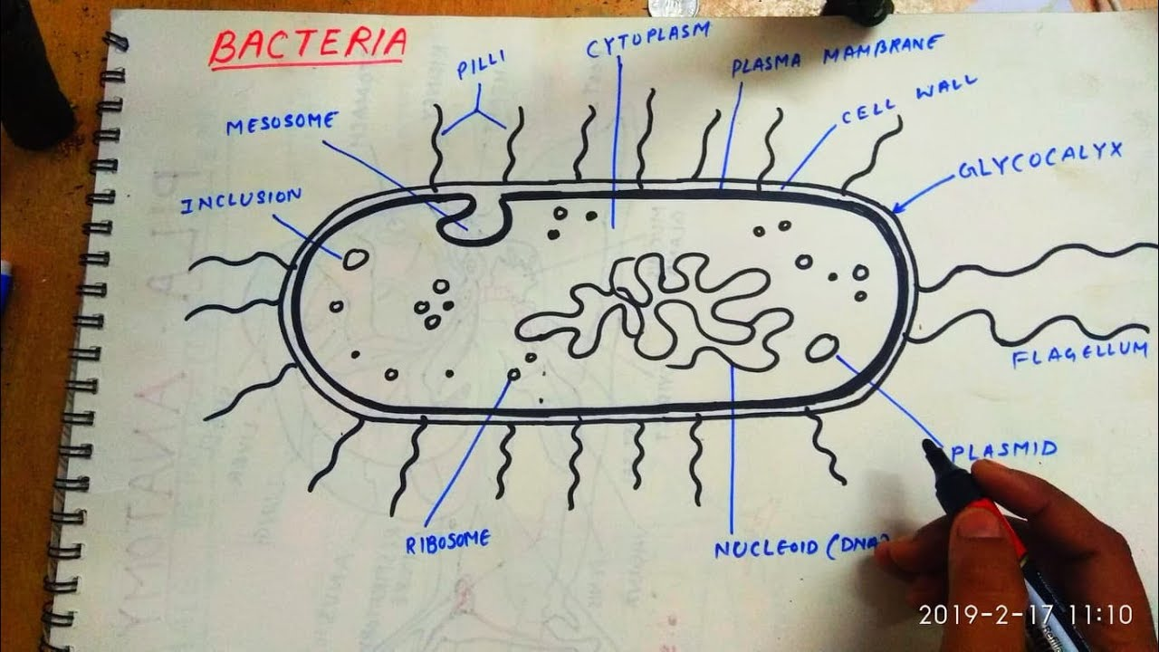

10.Analyze the structure of an animal cell by drawing a diagram. Label ALL of the following: plasma membrane, nucleus, rough endoplasmic reticulum, ribosomes, smooth endoplasmic reticulum, golgi apparatus, vesicle, lysosome, mitochondrion, cytoplasm, and cytoskeleton
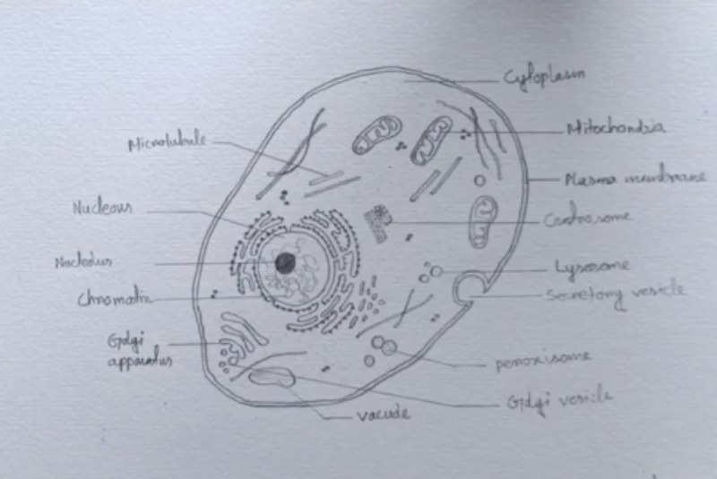

11.Analyze the structure of a plant cell by drawing a diagram. Label ALL of the following: cell wall, plasma membrane, nucleus, rough endoplasmic reticulum, smooth endoplasmic reticulum, golgi appratus, vesicle, central vacuole, mitochondrion, cytoplasm, and chloroplast

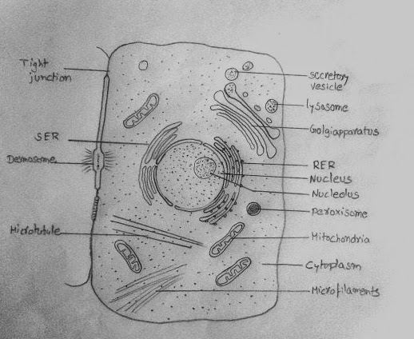

12. Comprehend the basic function of various organelles by completing the table below.

Organelle | Function
Nucleus | Stores the cell’s genetic information (DNA)
rER | Synthesize proteins.
sER | Synthesize lipids.
Vacuole | Isolating materials that might be harmful or a threat to the cell, containing waste products and water in plant cells.
Lysosome | Break down excess or worn-out cell parts. They also destroy invading viruses and bacteria.
Mitochondrion | generate energy for cells to carry out cell activities
Flagellum | Aid in locomotion, but it also often functions as a sensory organelle
Ribosome | Synthesize proteins
Plasma membrane | they keep toxic substances out of the cell, they also contain receptors and channels that allow specific molecules, such as ions, nutrients, wastes, and metabolic products, that mediate cellular and extracellular activities to pass between organelles and between the cell and the outside environment
Cell wall | Provides tensile strength and protection against mechanical and osmotic stress. It also allows cells to develop turgor pressure, which is the pressure of the cell contents against the cell wall.
Chloroplast | convert light energy into relatively stable chemical energy via the photosynthetic process
Central vacuole | stores water and maintains turgor pressure in a plant cell
Cytoskeleton | Helps cells maintain their shape and internal organization, and it also provides mechanical support that enables cells to carry out essential functions like division and movement.
Nuclear envelope | envelope keeps the contents of the nucleus, called the nucleoplasm, separate from the cytoplasm of the cell

- Diffusion is the movement of substances from a region of high concentration___________ to __a region of low concentration until equilibrium is reached.

- During osmosis, water molecules moves into or out of cells through the
A semi-permeable membrane, from low solute concentration to a region of high solute concentration, until equilibrium is reached.

- During the process diffusion, a transport protein moves ions or molecules across the plasma membrane from a high solute concentration to a region of low solute concentration, until equilibrium is reached.

- ATP, a form of energy cells use, must be used during active transport.

- Contrast endocytosis and exocytosis by explaining how they are different.
Endocytosis is the transport into the cell and exocytosis is the transport out of the cell. The difference can be seen because a vesicle forms around the molecule entering in endocytosis and forms a vesicle.

